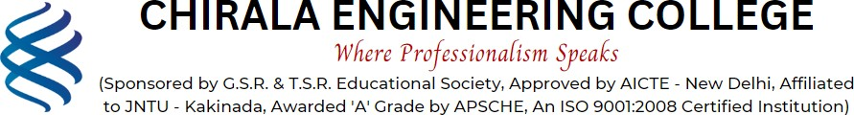

5.1.3: Guidance for competitive examinations and career counseling activities offered by institution:

Academic Year | Name of the Particulars | No: of activities conducted | No: of Students benefited | Links for Relevant Documents
2022-2023 | Report on activities conducted as guidance for competitive examinations and career counseling | 7 | 493 | http://www.cecc.co.in/wp- content/uploads/2024/04/5.1.3-22-23.pdf
2021-2022 | Report on activities conducted as guidance for competitive examinations and career counselling | 5 | 451 | http://www.cecc.co.in/wp- content/uploads/2024/04/5.1.3-21-22.pdf
2020-2021 | Report on activities conducted as guidance for competitive  examinations and career counselling | 8 | 486 | http://www.cecc.co.in/wp- content/uploads/2024/04/5.1.3-20-21.pdf
2019-2020 | Report on activities conducted as guidance for competitive examinations and career counselling | 6 | 702 | http://www.cecc.co.in/wp- content/uploads/2024/04/5.1.3-19-20.pdf
2018-2019 | Report on activities conducted as guidance for competitive examinations and career counselling | 3 | 992 | http://www.cecc.co.in/wp- content/uploads/2024/04/5.1.3-18-19.pdf

